Reunite Lovers With A Love Spell From Top Psychic
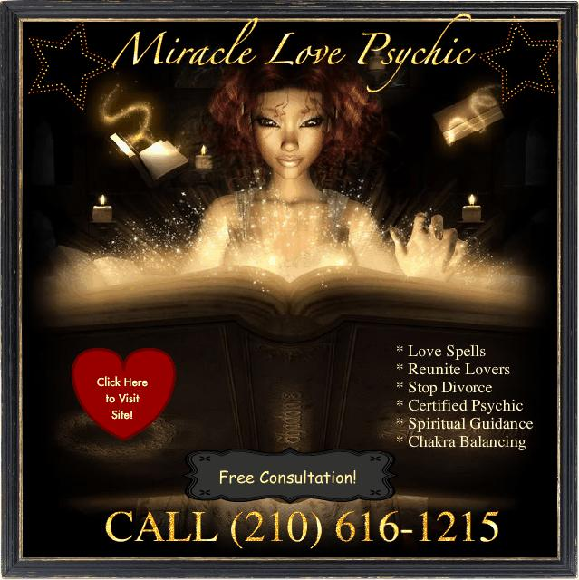
(1888PressRelease) Nadia Foster has been assisting people with love spells for over 20 years and now making her online debut
(1888PressRelease) - Nadia Foster is a God gifted love spell Psychic whose abilities are god gifted indeed. For over 20 years, Nadia has been assisting people with relationships and stopping impending divorce. Nadia has helped so many people that some of them are helping to spread her word and her work on love spells.
Nadia specializes in mending broken hearts, but also conducts tarot readings as well. Nadia can not make anyone fall in love with you, only lost loves or separated love ones. The gifted psychic is honest, she will inform you if you and your separated love one are compatible or not. The psychic hailing from San Antonio Texas is becoming more and more popular with her ethics and her ability to help people. Since the launch of her website, Nadia has become more and more popular as her work spreads.
Unlike other love spell casters of the like, Nadia has a free consultation, in which she will give you an honest answer if she can help you and your love one reunite and if you are compatible. For a Free consultation call Nadia 210-616-1215 or visit her site Now at
http://www.reuniteloverspells.com.
Trackback URL:
http://www.1888pressrelease.com/love-spells/reunite-lovers/reunite-lovers-with-a-love-spell-from-top-psychic-pr-237083.html
###

