RBA Seizes Vehicles Enforces Judgments
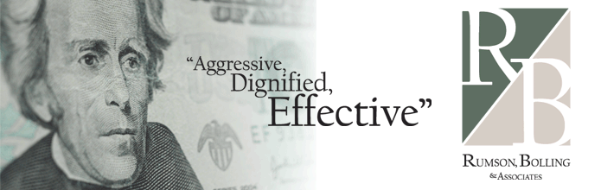
(1888PressRelease) Rumson, Bolling & Associates efforts are amplified during the judgment enforcement phase of RBA's collection service. Rumson Bolling & Associates works hard to obtain money and assets that are owed to its clients.
Los Angeles-Long Beach, CA (1888PressRelease) - RBA's premium forwarding fee services allows clients to place multiple cases directly into collection litigation for an upfront forwarding contract fee (FFC). The FFC allows clients to pay discounted costs for debt collection litigation services.
Rumson, Bolling & Associates full service debt collection services start with standard collections, and through the course of debt collection RBA puts pressure on your debtors to pay your debt. Unlike other agencies that close their files or reduce their efforts during the post-judgment phase, RBA increases, amplifies and ramps up its post-judgment collection efforts. RBA works for success from the start of your case to the closure of your case.
There are numerous under-utilized post-judgment remedies that RBA regularly employs including assignment orders, wage garnishments, keeper levies, bank levies and property seizures for subsequent sale at auction. RBA uses fulltime bank account locators and submits all of its judgments for nationwide cyclical bank account searches at no additional charge. Don't let your agency close its file on you send your judgment to RBA.
In this article presents a gallery of examples of photos of recently seized vehicles to be sold at auction in order to fulfill judgments RBA has obtained.
http://www.rumsonbolling.com/
Trackback URL:
http://www.1888pressrelease.com/seize-vehicle/judgment/rba-seizes-vehicles-enforces-judgments-pr-290521.html
###

