Corcentric Announces New National Account Manager
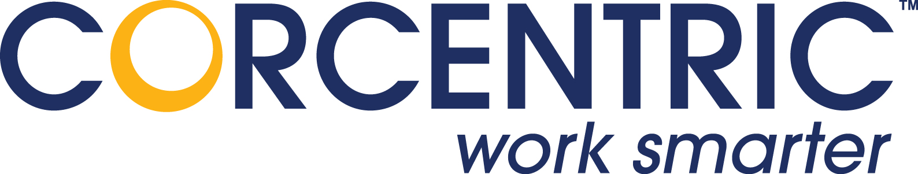
(1888PressRelease) James Wright Will Lead New Business Sales and Strategic Partnerships for Corcentric's Accounts Payable Automation Solution, COR360.
(1888PressRelease) - McLean, VA - Corcentric, a leading provider of accounts payable automation solutions, today announced the appointment of James Wright as National Account Manager. He brings over 15 years of consultative sales experience to Fortune 1000 companies, focusing in the area of Accounts Payable Automation.
Mr. Wright is responsible for building the client base for Corcentric's accounts payable solution, COR360, which enables companies to manage 100% of their paper and electronic invoice submissions, invoice approvals and matching, supplier customer service, purchase order requisitioning, payment disbursement, and spend management. "I am looking forward to building new relationships for the Corcentric team. This is an excellent opportunity to join a rapidly growing company that offers a comprehensive AP automation solution," said Mr. Wright.
Wright previously worked for Archive Systems as an Account Executive where he was a leading force behind the sales and growth of ASPEN Accounts Payable. He was responsible for acquiring key accounts as well as partnering with Ariba and the Ariba Supplier Network. He also previously worked for Ariba and Ceridian, gaining a strong background in accounts payable outsourcing.
"In our search for the National Account Manager position, we were looking for someone with deep solutions-based selling experience who could accelerate the growth of our COR360 accounts payable automation solution. We are confident that James's past success in AP software sales will provide us with significant results. We're pleased to have him join our group," said Dave Lindeen, Vice President of Corcentric.

About Corcentric
Corcentric is a leader in providing accounts payable automation solutions that are powerful, yet easy-to-use; giving companies an easy-to-adopt conduit between AP/AR and suppliers with uncompromising functionality. Corcentric builds customized solutions that allow clients to electronically mange 100% of their invoices, resulting in increased revenues and reduced business costs. For more information about Corcentric, contact Dave Lindeen, Vice President, at (630) 925-7677 or visit the Website at www.corcentric.com.
Trackback URL:
http://www.1888pressrelease.com/ap-automation/e-invoicing/corcentric-announces-new-national-account-manager-pr-254310.html
###

