Solutions to America's Economic Problems by Paul Chehade
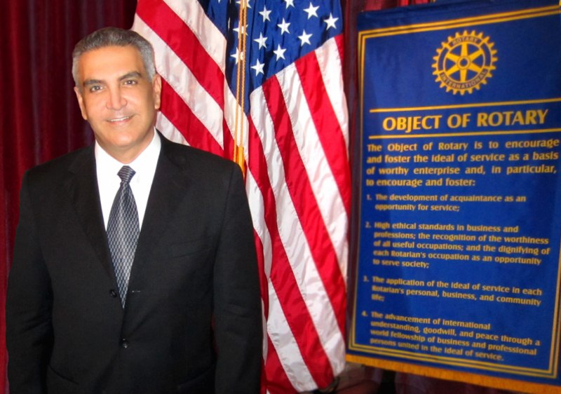

(1888PressRelease) The United States is facing economic disaster on a scale few nations have ever experienced. Most people are unaware of the easily observable signs of this emerging crisis. While we persist in our superpower mentality, we have quietly become a second-class country in many respects. Paul Chehade:.
(1888PressRelease) July 23, 2012 - Major Economic Concerns Facing the United State
The United States is facing economic disaster on a scale few nations have ever experienced. Most people are unaware of the easily observable signs of this emerging crisis. While we persist in our superpower mentality, we have quietly become a second-class country in many respects. Paul Chehade:.
We no longer manufacture what we need to sustain ourselves, we import much more than we export, and we are selling off our assets and taking on massive debts to sustain a standard of living we can no longer afford. Not only is this not the way America became a superpower but it is a sure way to lose this status.
We are failing even to acknowledge predatory foreign trade practices undermining US industry. Instead we encourage US manufacturers to design, engineer, and produce in third world markets like Mexico and China.
Reversing the Trend: Some Suggestions for Action
Access to our markets must be conditioned on a strategic analysis of our own national needs first and foremost. As things stand, we have handed our sovereign rights to our domestic markets to international bodies like the World Trade Organization and are committed to disastrous "one-way free trade" agreements such as Value Added Tax regulations and NAFTA. We are in a dramatically different position from emerging low-wage markets. They have everything to gain, and we have everything to lose. Our policies should carefully protect our wealth and resources rather than simply provide the lowest consumer cost regardless of the impact on our industries and our workers.
Promoting open markets and economic growth abroad will not alone rebalance America's trade accounts and domestic industrial collapse. Our industries have been so disarmed and dismantled that we now lack the knowledge, capacity, and investment capital to facilitate self-sustaining production. Dramatic new direction is required.
Key Solutions
Drastic action is needed to restore our economic and financial independence and we must begin immediately to rebuild our industries. The first essential is that our government should ensure that it is once again profitable to produce most goods and services in American factories employing American workers.
We must establish policies that prevent other countries from doing to us what they would never let us do to them. Specifically,
• We must halt the sale of key assets to foreign entities.
• We must also close opportunities for foreign corporations to compete unfairly against our home industries.
• We should move immediately to curb our out-of-control spending on unnecessary programs and initiatives that are being financed by foreign debt.
• We should institute policies to cut back our consumption, and particularly consumption of imported products.
• We should look to the way other nations have established industrial superiority over us and try to copy their best policies.
• We should not allow individuals and companies to profit by selling out the Unites States.
No plan to revive our economic and industrial self-sufficiency will be pain-free. Because our industrial decline has already gone so far - it has been proceeding rapidly for more than 30 years already - restoring our industry to world-leading standards of competitiveness will require serious restrictions on trade and investment flows. Despite indisputable evidence that current policies have proved grossly inadequate or even counterproductive in the past, our leaders remain committed to a business-as-usual strategy that is doomed to failure.
The stimulation for new policies must come directly from the broad American public. Voters must use all reasonable methods to pressure elected officials. Without direct and immediate action, there will soon be little left to save.
Defense
Our industries, assets, resources, and companies need to be protected from foreign countries and corporations seeking to gain control of key industrial processes and technologies. This would include preventing the sale of strategic US domestic companies to foreign companies and eliminating offshore outsourcing except in extreme circumstances.
Fair Trade
Our trade treaties should protect our country from predatory foreign countries and companies seeking to weaken or destroy American industry. To that end, tariffs should be erected where needed and where practical. Experience has shown that it is futile to expect other countries to adopt our policies on, for instance, fair and free competition.
What we can do is control the impact of their policies on our economy. The most obvious tool we have is tariffs on their exports. No doubt our tariffs would set off retaliation abroad. We would also have to accept that demand for US debt would decrease. But in the long run, these negatives would be much more than offset by positive effects as American entrepreneurs and industrial executives enjoyed a massive incentive to renew our industrial base.
Domestic Industry Competitiveness
In addition to establishing protection for our industry and country, we should properly align our companies with the national interest by changing the incentive system within which they operate. The tax structure should be changed to encourage industrial revival, particularly in industries which have been hit worst by unfair foreign competition. One simple but highly effective measure would be to shorten the depreciation schedules on capital investment and research spending. Meanwhile capital gains taxes should be increased to discourage short-term thinking and reduce the incentive for entrepreneurs to cash out.
Suggested Solutions to America's Economic Problems
The following suggestions should be considered as part of a new plan to recover American industry and economic health:
• Appoint an economic minister, a major cabinet post, to develop an industrial policy that would:
1. Create conditions to make manufacturing competitive and profitable through tax changes and subsidies where needed
2. Protect our economy from foreign predatory practices
3. Create an industrial research and development division similar to government sponsored National Institute of Health (NIH) in medicine or the Apollo project.
Or, copy Japan's very successful system conducted by their Ministry of International Trade & Industry (MITI) that focuses on needs and development procedures for their new and existing industries.
• Change the tax structure for select industries that are vital to strategic American interests - steel, transportation, cement and others.
• Control the balance of trade deficit. The majority of this money leaves our economy and never returns. The money that does return is the means through which foreign companies are able to accumulate funds to purchase our best companies.
• Amend or get out of our agreement with the World Trade Organization. It places our domestic trade laws in the hands of an undemocratic organization whose decisions have been consistently and unfairly adjudicated.
• Eliminate the foreign Value Added Tax (VAT) discrepancy. It unjustifiably subsidizes foreign exports to us, while simultaneously penalizing our exports to them.
• Amend or get out of NAFTA. It incentivizes our companies to move productive facilities out of our country.
• We must analyze every international trade deal by considering if it benefits America; currently most deals do not.
• Use tariffs selectively to prevent the loss of strategic and endangered industries.
• Curtail subsidies foreign owned companies receive from state governments and discourage technology transfer and outsourcing manufacturing that results in the loss of industries.
• Prevent the sale of strategic companies or institutions to foreign ownership.
• Faster depreciation on capital equipment investment - it will lessen the need to outsource manufacturing.
Free trade has been a disaster. It must be replaced with intelligent trade that prevents foreign predatory practices and better serves U.S. interests.
OTHER THINGS TO CONSIDER:
• We must strive to become competitive; otherwise America must exist on imports with more debt,
• American owned companies have lost their edge and, on balance, are not as productive or as protective as many other foreign companies. This must be corrected.
• It must be profitable to manufacture in America otherwise domestic companies will outsource their manufacturing.
• America is losing a major economics war by relinquishing management and control of the economy through effects of our balance of trade deficit, outsourcing, subsidized insourcing and foreign tax benefits.
• Consider the consequences of losing whole industries such as publishing, autos, movies, steel, electronics, clothing and how it impacts national security and living standards.
• We need to analyze and correct:
1. Negative effects of World Trade Organization rules and decisions regarding their impact on our economy.
2. Violations of World Trade Organization rules practiced by other countries to our detriment.
3. Restrictions imposed by foreign governments on American exporting companies.
God bless America!
Sincerely,
Paul Chehade:.
www.paulchehade.org
Trackback Url :
http://www.1888pressrelease.com/paul-chehade/economic-problems/solutions-to-america-s-economic-problems-by-paul-chehade-pr-411762.html
###

