Scott Miller Cash Gifting Trainer Gives Back
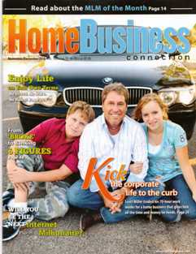
(1888PressRelease) While many internet marketers seem to believe they owe the world nothing... Scott Miller Cash Gifting Trainer believes it's an obligation to give back to the community
(1888PressRelease) - Scott Miller Cash Gifting Trainer has become a well-known network marketer. In addition to his successful internet marketing endeavors, Scott Miller Cash Gifting Trainer has also participated in many different charitable organizations.
He has hosted or participated in numerous charity events, such as the recent Children's Miracle Network at the Oak Hill Mansion. February 18, 2011
He also has his own foundation which, according to its website, helps children in need "through contributions to the arts, education, and healthcare."
Scott believes there is no greater cause than helping children. "It is through education that children will be able to better their lives", which makes this an especially honorable cause.
Scott Miller is also supported by a legion of internet marketing students and fans. Scott Miller's student's success stories are legend within the internet marketing world. Some of the now top performers in the industry started as Scott Miller's cash gifting students.
Scott Miller 's cash gifting students have not only taken his lead and training to improve their own lives, but MANY have followed his lead in charitable contributions of both time and money. It takes a very special person to inspire others to make such a large impact in the world. As a mentor and leader, Scott Miller has been able to inspire countless people to make a difference in the world in whatever way they can.

http://www.cash-gift-trainer.com
Trackvack URL:
http://www.1888pressrelease.com/scott-miller-cash-gifting/scott-miller/scott-miller-cash-gifting-trainer-gives-back-pr-304564.html
###

