New look for the summer and beyond
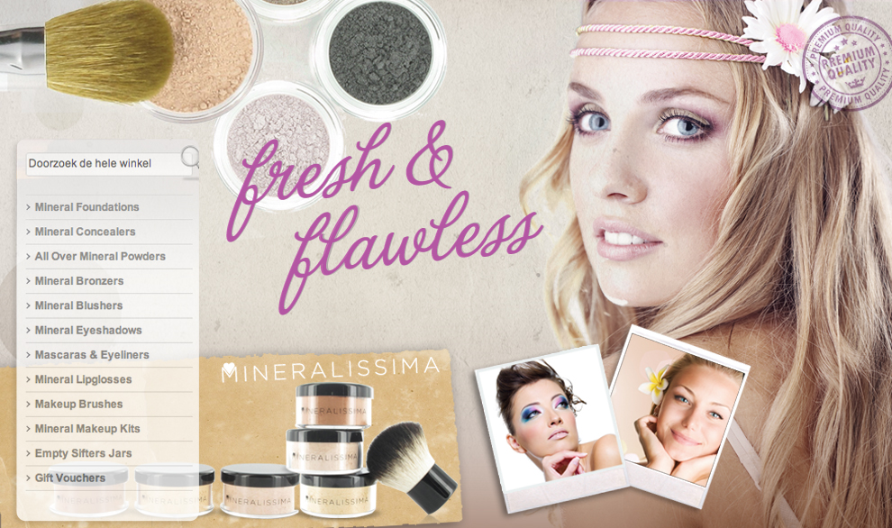
(1888PressRelease) A dutch mineral makeup company launches their renewed webstore revealing a new, fresh look and new products.
(1888PressRelease) - Natural cosmetic company Mineralissima today reveals a completely new, fresh look http://www.mineralissima.com. Reflecting its international success the re-design enables easy and intuitive online shopping in seven languages: English, French, Finnish, German, Spanish, Dutch and Italian.
Mineralissima stresses a commitment to healthy and natural skin care. Product ranges include the quality, healing benefits of pure crushed minerals to achieve flawless makeup results. The extensive and affordable product-line includes foundations, blushers, eyeshadows, concealers, mascaras, lipglosses, brushes and complete makeup kits.
The popularity of the brand has led the company to develop an easy to navigate site for both individual shoppers and wholesale purchasers.
Founder Kati Launonen said 'summer time is all about nature, health and beauty so it is the perfect time to launch our new look. We hope our redesigned website will make the Mineralissima experience all the more enjoyable for summer and beyond'.
Particular attention has been paid to safe shopping online. Mineralissima takes security seriously and has an SSL certificate for customer peace of mind.
Mineralissima keep it simple. Be Natural. Be Beautiful
About Mineralissima
Mineralissima strongly believes in making healthy options when it comes to your skin, and that these options should not come at a cost to nature or your wallet. Founded in 2007 from the love of mineral cosmetics, Mineralissima represents the core of effective and gentle mineral beauty products. The company offer a complete line of mineral makeup to promote healthier, flawless skin without the hefty pricetag and unnecessary animal testing. Mineralissima understand that the skin is a living organism and that the minor ingredients in cosmetics matter just as much as the major ones.
http://www.mineralissima.com
Trackback URL:
http://www.1888pressrelease.com/new-look-for-the-summer-and-beyond-pr-313711.html
###

