SWAT Radon Mitigation Promotes National Radon Testing Month, January 2012. Discounted Radon Systems Offered By SWAT Radon Mitigation
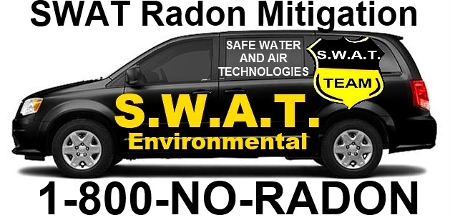

(1888PressRelease) SWAT Radon Mitigation is America's Premiere radon gas remediation, abatement, testing, and radon removal contractor. The World Health Organization has reserved January 2012 as "National Radon Action Month." According to Ross Aton, Environmental Specialist with SWAT Radon Mitigation, "Radon gas is one of the leading causes of death in America when it comes to air pollution."
(1888PressRelease) Lexington, KY - According to SWAT Radon Mitigation, radon is responsible for over 20,000 lung cancer deaths each year in the U.S. and over 100,000 world-wide. The National Cancer Institute and American Lung Association have joined forces to fight America's second most common cause of lung cancer. The awareness campaign will be promoted during the month of January, 2012. National Radon Awareness Month will kick off the drive to cure the problem.
Radon is formed as part of the normal radioactive decay chain of uranium and thorium. Uranium and thorium have been around since the earth was formed and their most common isotope has a very long half-life (4.5 billion years). Uranium and thorium, radium, and thus radon, will continue to occur for millions of years at about the same concentrations as they do now. As the radioactive gas of radon decays, it produces new radioactive elements called radon daughters or decay products. Radon daughters are solids and stick to surfaces such as dust particles in the air. If contaminated dust is inhaled, these particles can stick to the airways of the lung increasing your risk of developing lung cancer.
According to Jim Gelina, a radon professional with SWAT Radon Mitigation, "radon is a common problem throughout the U.S." Radon is responsible for the majority of the public exposure to ionizing radiation. It is often the single largest contributor to an individual's background radiation dose, and is the most variable from location to location. Radon gas from natural sources can accumulate in buildings, especially in confined areas such as attics and basements. It can also be found in some spring waters and hot springs.
SWAT Radon Mitigation is leading the drive to reduce the public's exposure to this toxin. Epidemiological studies have shown a clear link between breathing high concentrations of radon and incidence of lung cancer. Thus, radon is considered a significant contaminant that affects indoor air quality worldwide. "Although elevated radon levels can be found in millions of American homes, the problem is relatively easy and inexpensive problem to fix," states Ben Ingalls. His firm, Air Quality Control Agency, installs radon mitigation systems throughout Colorado.
The United States Environmental Protection Agency states that radon is the second most frequent cause of lung cancer, after cigarette smoking, causing 21,000 lung cancer deaths per year in the United States. About 2,900 of these deaths occur among people who have never smoked. While radon is the second most frequent cause of lung cancer, it is the number one cause among non-smokers, according to EPA estimates.
Jeff Finken, a radon mitigator with Accredited Radon Mitigation is offering discounted prices for installation of radon remediation systems. "We are happy to help in any way that we can. Installing radon mitigation systems is our way of fighting lung cancer" states Finken. His firm has recently joined an alliance with SWAT Radon Mitigation to help reduce lung cancer for low income families by installing radon removal systems in hundreds of homes. They are calling it the "Radon Abatement Project of 2012." National Radon Action Month (NRAM) is the perfect time to kick off the campaign. You can learn more by visiting www.RadonMonth.org or by calling 1-800-NO-RADON.
http://www.MitigationSystem.com
Trackback Url :
http://www.1888pressrelease.com/swat-radon-mitigation-promotes-national-radon-testing-month-pr-357864.html
###

