New material produces Hydrogen for fuel
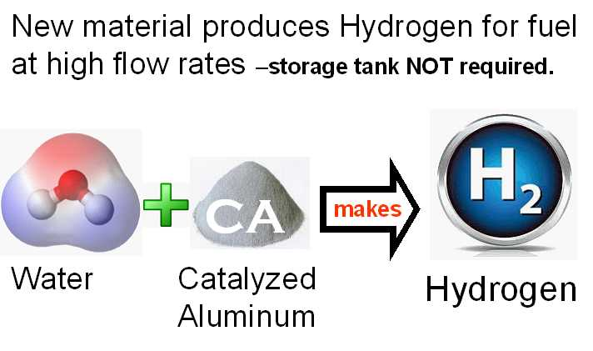

(1888PressRelease) The unique thing about the new material is that it can produce hydrogen at any flow rate desired. That eliminates the need for storage tanks and lowers the cost of hydrogen fuel. One pint of the new CA material can produce hydrogen at a flow rate that is higher than that required to increase the MPG of an automobile by more than 32%.
San Jose, CA - Yes, it is that simple -- A new material makes hydrogen when it is added to warm water. The new material was produced in a research program to find a new and better way to produce hydrogen-on-demand for use as a supplemental fuel for engines that burn petroleum.
Catalyzed Aluminium (CA), the new hydrogen-producing material, is now available for commercialization of systems that will use hydrogen for fuel supplements. Samples of the new material are available from Phillips Company.
32% to 40% increases in miles per gallon have been demonstrated by simply adding a small amount of hydrogen to the air used by an automobile engine.
The unique thing about the new material is that it can produce hydrogen at any flow rate desired. The flow rate can be scaled up by simply increasing the amount of CA that is used in the vessel used to produce hydrogen. One pint of the new CA material can produce hydrogen at a flow rate that is higher than that required to increase the MPG of an automobile by more than 32%.
Hydrogen fuel storage tanks are no longer needed because of this new low-cost, safe method for producing hydrogen fuel at high flow rates using a mixture of aluminum and carbon, two of the world's safest and lowest-cost industrial materials.
The hydrogen-from-water breakthrough was a result of a catalytic chemistry development that successfully splits water to produce hydrogen, while retaining oxygen in the water. That breakthrough was rapidly used to develop CA which is a mixture of aluminum and catalytic carbon. CA fuel is a material that is engineered and optimized to generate hydrogen by simply adding warm water to the CA material.
For many years, experts have agreed that hydrogen will command a key role in future renewable energy when a relatively cheap, safe, efficient and non-polluting means of producing hydrogen can be developed, on demand, at very high rates which make hydrogen storage tanks unnecessary. That goal has been achieved, for the first time, using the new CA process.
Before this new process was developed, the use of hydrogen fuel was limited by the lack of an inexpensive catalyst that can speed up the generation of hydrogen from water. A vital part of the CA development success was combining predictive theoretical chemistry and verification testing to accelerate the process of identifying catalytic carbon as a new catalyst for use with aluminum to split water and obtain hydrogen.
Fuel cost is important. The fuel for this process is water and CA. This process converts water into hydrogen fuel. When hydrogen is produced, water is consumed at a greater rate and CA is consumed at a lesser rate. CA is made from scrap paper and scrap aluminum -- providing the dual advantage of low cost and recycling of scrap materials.
Catalytic chemistry research resulted in the discovery that an inexpensive activation process can convert normal carbon into a carbon catalyst that can effectively generate hydrogen gas from water, using a small amount of aluminum. The aluminum does not have to be pure, making the fuel less expensive. CA is made from scrap aluminum to keep the cost down.
The CA process does not require electrolytes or organic additives. It can operate in pH-neutral water, even if it is dirty, and can operate in sea water, the most abundant source of hydrogen on earth.
Hydrogen purity measurements were made by an independent test laboratory. Hydrogen was produced in the test laboratory using aluminum and catalytic carbon. The process produced 93% pure hydrogen with 7% water vapor.
Hydrogen is an energy dense and clean fuel, which upon combustion releases only water vapor. Today, most hydrogen is produced from electrolysis which requires large amounts of electrical energy or from natural gas thermoforming which results in excessive carbon-dioxide emissions. An alternative, clean method is to make hydrogen from water using Catalyzed Aluminum.
The unique thing about this new process is that it requires no power input after the hydrogen-producing reaction is started and brought to thermal equilibrium; making possible, for the first time, the scale-up to high rates of hydrogen on demand (HOD). A hydrogen output of 1 liter per minute can be achieved with the CA consumption of only 0.67 grams/minute. This is about three times more hydrogen flow rate than is needed for a typical automobile to increase the gas mileage by 32% to 40%.
The new material used to produce hydrogen is called Catalyzed Aluminum, CA, which is a hydrogen-on-demand process. The hydrogen production rate is controlled by water temperature. Water is two-thirds hydrogen. Heating the water to about 180F causes water to be split by the CA, thereby releasing hydrogen in the form of a gas which can be used for fuel. When hydrogen from this process was added to the air intake of an otherwise unmodified Buick test vehicle, mileage improvement ranged from 32% to 40%.
The CA material is made from scrap materials -- aluminum and paper. These two materials are oxidized at a high temperature which reduces the paper to carbon. This step in the process is much like a "controlled burn," carried out at temperatures high enough to carbonize paper but lower than the melting temperature of aluminum. The aluminum-carbon mixture is then chemically activated to transform the carbon into catalytic carbon.
The name CA denotes catalyzed aluminum. The aluminum is not a catalyst, but it is catalyzed by the presence of catalytic carbon. CA is mostly aluminum, with a carbon content less than 2%. The carbon is in direct physical contact with the aluminum, making the hydrogen production process more efficient.
Safety is an important issue. Catalyzed Aluminum is intended to be used to produce hydrogen as a fuel. This material (CA) can be handled quite safely; but there are real hazards if it is not handled and used in a safe manner. The CA granule size is about 0.2 mm, making it safe to handle in dry air. CA is not atomized and it is not aluminum dust. Handling and storage of aluminum granules is much more safe than the handling and storage of gasoline, diesel or other hydrocarbon fuels. A safety-engineering analysis summarized the comparison of fuels by noting that "in the worst case of an automobile accident, would you rather have volatile and explosive gasoline leaking all over the place or would you rather have non-flammable water and aluminum?"
The CA material contains Catalytic Carbon. CC has been provided to 45 evaluation sites internationally with very positive results. Independent evaluators have produced hydrogen at high flow rates ranging from 1 to 40 liters per minute. The process produces high-purity hydrogen because when the water is split, the oxygen remains in the water in the form of aluminum hydroxide.
Converting existing engines to use CA is the next step toward commercialization. The new Catalyzed Aluminum fuel was developed by a pharmaceutical manufacturing company. Phillips Company is not an energy products company. Accordingly, the development and commercialization of hardware products will be done by other companies.
The chemistry technology is completely developed, well understood, and ready for commercialization. "We are in discussion with potential licensees. Business agreements with additional licensees, particularly manufacturing companies, are planned," said a company spokesman.
Phillips Company is searching for companies that can produce hardware and commercialize the technology in the form of supplemental fuel for vehicles, hydrogen fuel for heating, and hydrogen fuel for water distillation. "We think using hydrogen to fuel ships is promising because the process works well with sea water. More importantly, we think it makes sense to use hydrogen to fuel electric power generators on islands or in remote locations where water is plentiful and cheap, compared to the cost of importing oil/diesel via tanker ships," said a spokesman for the company.
These applications are now possible because this process is the world's first process that can be scaled up to produce hydrogen on demand at very high flow rates. Because the hydrogen-producing process can uses pH-neutral chemistry, the hardware corrosion problems can be virtually nil.
In the 2012 State of The Union address, the President said, "This country needs an all-out, all-of-the-above strategy that develops every available source of American energy - a strategy that's cleaner, cheaper, and full of new jobs." Most Americans agree. "We are searching for companies that can become strategic alliances to produce the equipment and commercialize the use of hydrogen for fuel," said A. Shravah, the licensing agent for Philllips Company. He can be reached at ashravah ( @ ) gmail dot com
via email.
Bion Energy, Ltd. is Phillips Company's strategic alliance and authorized agent in England. The Bion Energy organization is seeking global partners for the roll-out and application of this technology; particularly in the Caribbean, Africa, Middle East and South America. Please contact Fred Davey, Bion Energy at Fred.davey ( @ ) bionenergy dot co dot uk
or through our web site.
Samples of hydrogen-producing Catalytic Aluminum are available from Phillips Company. The CA process for producing hydrogen from water is described in more detail online at http://www.PhillipsCompany.4T.com/CA.pdf
Phillips Company can be reached by email; hp ( @ ) valliant dot net
http://www.PhillipsCompany.4T.com
###

