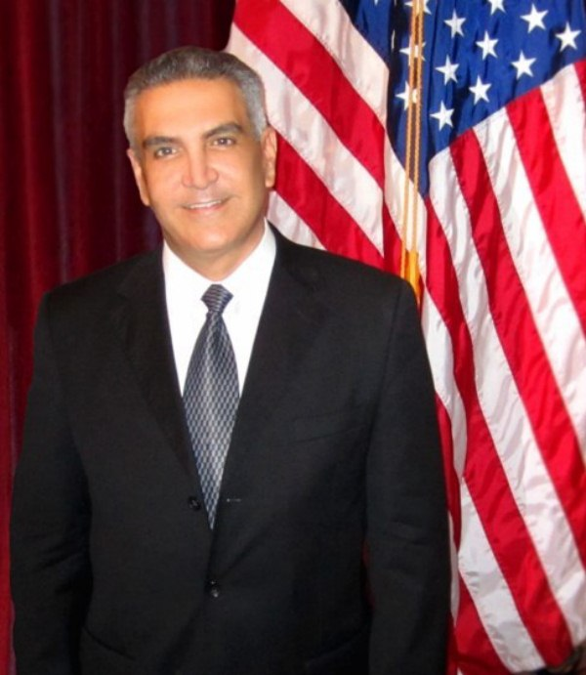
Paul Chehade Is Register As A United States Presidential Candidate For The 2016 Election

1888 PressRelease - Paul Chehade, announced today that his candidacy has officially applied with the US Federal Election Commission and has been approved as a Presidential Candidate for the 2016 Election.

The National Election Committee for the U.S. Presidential candidate Paul Chehade, announced today that his candidate has officially applied with the US Federal Election Commission and has been approved as a Presidential Candidate for the 2016 Election.

The official statement of candidacy can be viewed below:

Federal Election Commission:

CHEHADE, PAUL
CHALLENGER
Office Sought: President
Election Year: 2016
State: Presidential Candidate
Party: IND (Independent)

Paul Chehade Ideology complete:

Paul Chehade was born in Wilmington, Delaware on October 26, 1965. He is a political truth and righteous seeker, successful business entrepreneur, humanitarian rights activist and ideologist, polyglot, musician, writer; was and has sophisticated his character by a plan of virtues, which he believes in and continues to practice in order to develop his uprightness which it is the foundation for his solid moral.

Such moral is based on respect for the human customs and believes, knowledge, religious tendencies (as long as those do not hurt society but do provide love, brotherhood and progress in peace and harmony) regardless of color, race and culture.

His character is based on Temperance, Discipline, Silence, Order, Resolution, Frugality, Industry, Sincerity, Justice, Moderation, Cleanliness, Tranquility, Chastity, and Humbleness.

Paul Chehade is a believer of the practical and democratic values of prudence, hard work, education, honesty, spiritual development, self-governing institutions and opposes to authoritarianism both political and religious based on scientific and tolerant values of the Enlightenment.

Paul Chehade supported the idea of basic rights and freedoms to which all humans are entitled. Human rights include civil and political rights, such as the right to life and liberty, freedom of expression, and equality before the law; and social, cultural and economic rights, including the right to participate in culture, the right to food, the right to work, and the right to education and health.

Paul Chehade is the Chairman of the Board of a diversity group of corporations since 1999, which are dedicated totally to serve the ill-timed humans, regardless of a person's religion, race, ethnicity, or gender, as a demonstration of God's unconditional love for all people, helping communities worldwide.

Ethical junction making choices easy.

Values & Principles:

Paul Chehade was born in a Catholic family. Based on the principles expressed in the Bible, which Paul Chehade has been raised with; profound values and the riches of his Christian traditions lead him to base his desire to serve the community in neighborly love as preached by Jesus Christ.

What is required is to return to the old fashion principles on morality, ethics based on respect to all living creature.

Being ethical is not the same as doing "whatever society accepts." Being ethical is to follow the rules that respect the human right and integrity.

An entire society can become ethically corrupt. Discrimination is a good example of a morally corrupt society. A reform to our values back to basics will provide the standards to a moral and righteous behavior.

Education is an avenue. Religious principles of love are also valid. God must prevail in our schools our daily life and our families. The family is the basis of our society and the future of our children therefore of our nation.

God Bless America.

For more information please visit: http://www.paulchehade.org

Follow Paul Chehade on Facebook:https://www.facebook.com/paulchehadeII

Follow Paul Chehade on Twitter: https://twitter.com/paulchehade

###

