ProjStream Announces The Release of BOEMax 2.5
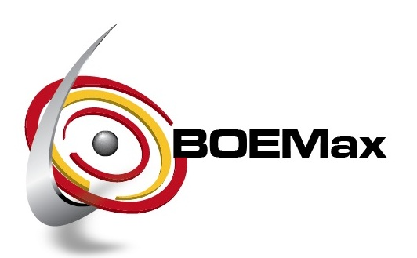

(1888PressRelease) ProjStream is unveiling a new version of their Basis of Estimate software, BOEMax 2.5, with enhanced capabilities. New release 2.5 helps users achieve more flexibility with new interface and user rich features.
(1888pressrelease) Orlando, FL - ProjStream, LLC today announced the release of the new BOEMax 2.5. BOEMax is a world-class estimating, proposal pricing, and cost analysis software. This version signifies a new user interface as well as new additional functionality beyond what version 2.0 provided. BOEMax will enable your project management staff to streamline the project lifecycle by interfacing with common scheduling tools, earned value engines as well as develop the basis of estimate package.
BOEMax 2.5 has enhanced features that now have more flexibility including Bill of Material Management, Cash Flow Analysis, Resource Calendars, DCAA Reports, Material Price Breaks, Apportioned effort, Manpower Analysis and much more. "We have made some of our existing functionality more robust," said Tom Shanahan ProjStream president and CEO. "Our primary focus at ProjStream is to not only listen to our customer base but act on their needs. Our design approach is such that we maintain a generic approach for the straight forward user, but add flexibility for the users that have a need to meet internal needs or needs of their customer. We achieve this flexible approach with configuration and parameterization in mind."
BOEMax 2.5 has a new look but also provides additional user rich features that make the job easier for estimators and pricing professionals. New features include on screen pivot grids, global change or logic builders, on screen filters, multivariate column sorting, drag and drop capability of columns, text editor formatting capability in text fields like Basis of Estimate fields. "ProjStream employs a rapid release cycle," said Paul Zecchini, Chief Technology Officer. "This allows us to deliver new features to our customers more expeditiously, plus learn from the feedback we are getting on existing features in order to deliver the functionality that our user base is requesting."
ProjStream LLC, headquartered in Orlando, FL provides many products and services in the Project Management arena. The main industry focus has been in the government contracting, federal agencies, EPC and energy industries.
On May 30, 2012 at 11 a.m. EST ProjStream will sponsor the latest BOEMax webinar, hosted by their expert, Tom Shanahan. Open for registration, the live webinar will focus on new features and enhanced functionality. You are invited! Join us for this free demonstration. If you would like to participate, email us now.
For more information, visit www.projstream.com to learn more about BOEMax.
Trackback Url :
http://www.1888pressrelease.com/projstream-announces-the-release-of-boemax-2-5-pr-395891.html
###

