FreeFonts.info - New Web Site with Thousands of Free Fonts

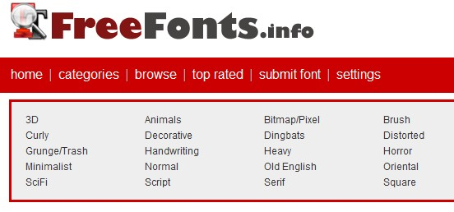

(1888PressRelease) FreeFonts.info offers over 13,000 fonts for free with no registration required. Users are able to download free fonts that come in thousands of different styles. People can also visit FreeFonts.info to submit their own fonts for others to use, creating a varied font community for users to share.
(1888PressRelease) - Recently launched, FreeFonts.info offers over 13,000 fonts for free with no registration required. Users are able to download free fonts that come in thousands of different styles. People can also visit FreeFonts.info to submit their own fonts for others to use, creating a varied font community for users to share.
FreeFonts.info is a website that gives visitors instant access to cool fonts. Upon visiting the page, people are able to download fonts that come in thousands of different styles from designers.
"A collection of the best free fonts on the Web, Browse a-z of over 13,000 fonts for free," said site owner John Gordon about his new website.
Fonts can be easily downloaded and some are also available for commercial usage - all this for free and no strings attached. All free fonts that are available at the site may be rated by users based on a 5-star system. Because of this feature, users are able to browse through the top rated fonts while looking for one to satisfy their needs.
Along with the main font categories, including 3D, Serif, Handwriting, Foreign, Gothic, Old English and Script font families, each offering dozens of subcategories, FreeFonts.info offers a custom text and custom colors to ensure the font would be suitable for user before downloading it. All pages can be bookmarked using popular social bookmarking services.
Visit FreeFonts.info and get the new experience of working online with freeware fonts for Mac and Windows.
FreeFonts.info is available at: http://www.freefonts.info.
Trackback Url :
http://www.1888pressrelease.com/free-fonts/download-fonts/freefonts-info-new-web-site-with-thousands-of-free-fonts-pr-407404.html
###

